
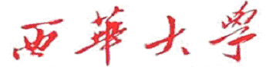
计算机与软件工程学院
上机实验报告

（ 2017/2018学年 第 2 学期 ）

课程名称 | Java EE技术开发
课程代码 | 150901089
任课教师 | 陆园
学生姓名 | 文攀锋 | 年级 | 2015
学号 | 3120150901107 | 专业 | 计算机科学与技术
实验成绩

实验名称 | 实验4： 综合实验——购物商城 |  |  | 实验地点 | 8-
实验类型 | 设计 | 实验学时 | 2 | 实验日期 | 2018/06/08
- 撰写注意：版面格式已设置好（不得更改），填入内容即可。
- 实验目的
综合应用MVC、Ajax、过滤器、数据库、分页等来进行编程。

- 实验内容

- 程序设计
1.实验步骤
(1)用户登录、注册。
(2)查看图书信息。
(3)选择购买的图书
(4) 实现将图书添加到购物车。
(5) 查看购物车。
(6) 修改购物车中商品数量。
(7) 移除购物车中指定图书。
(8) 清空购物车。
(9) 模拟结账。
2.设计要求
(1)使用MVC模式。
(2)使用Ajax实现局部刷新。
(3)使用过滤器解决编码、权限管理 。
(4) 实现分页。
(5) 使用C3P0、DBUtils等来完成功能。

3.详细设计
①．用户登录入口
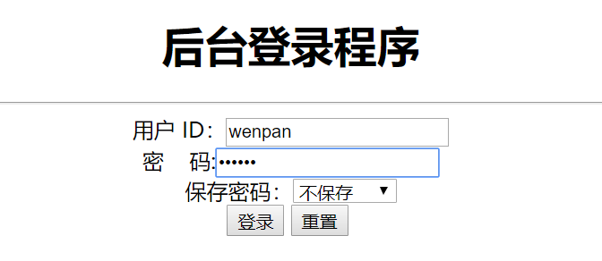

②．登录成功后跳转到欢迎页面，在欢迎页面可以进行选择“去购物首页”操作
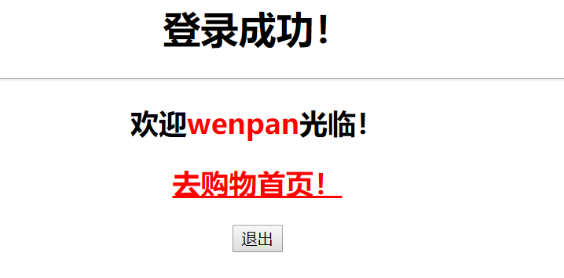
③．购物首页
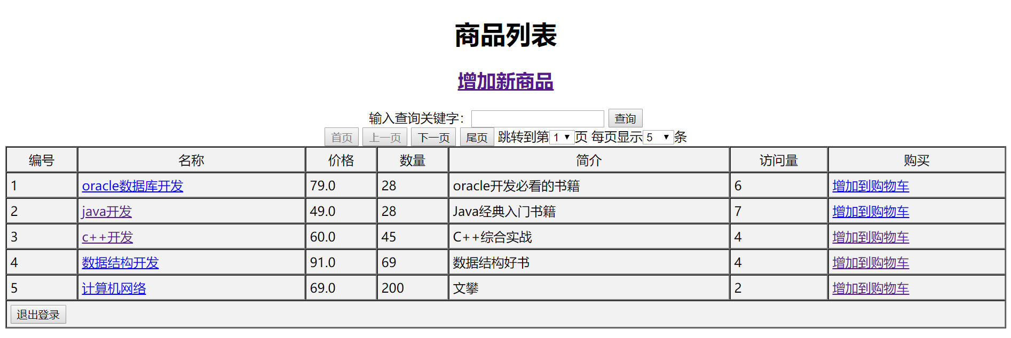
④．点击“下一页”进行翻页操作
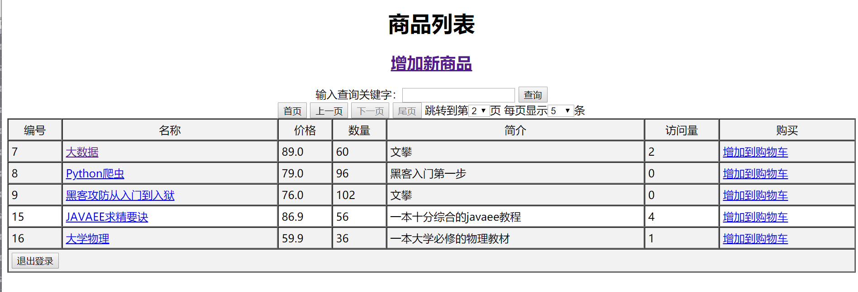
⑤．点击“增加到购物车”，进行模拟将商品加入自己的购物车，并且查看自己所购买的商品信息。
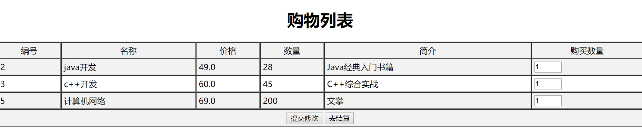
⑥．在自己的购物车中随意修改自己的购买数量，若不需要改图书，可以将图书的购买数量值改为0，模拟从购物车移除图书，并点击“提交修改”进行保存
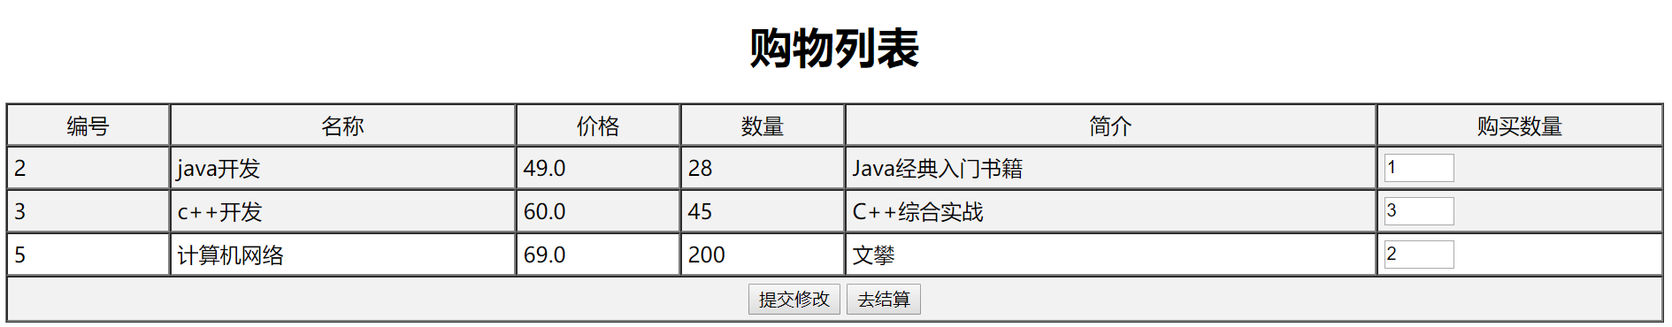
⑦．购买好商品后点击“去结算”,跳转到结算页面，模拟用户支付。在结算清单中 可以查看自己应支付的费用，也可以修改自己的登录信息。
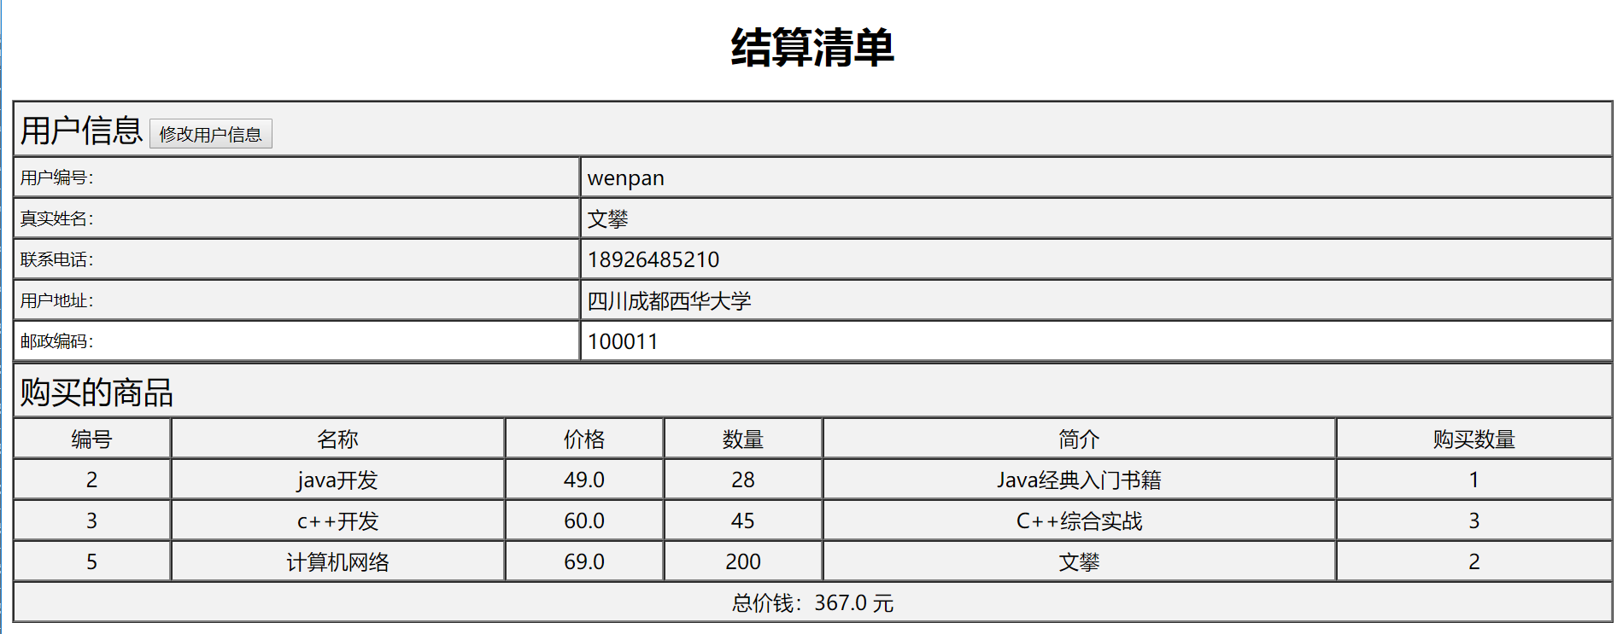
⑧．点击结算清单页面上的“修改用户信息”修改用户的登录信息，修改完毕后点击“确认修改”。
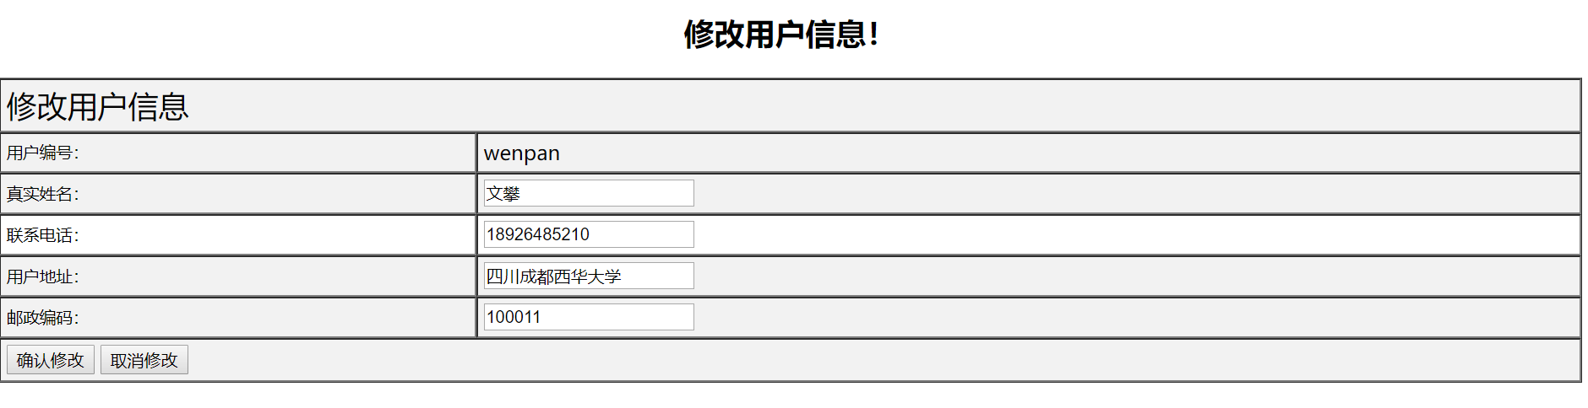
⑨．点击商品列表中的书的名称，即可查看书的详细信息，在此页面上你任然可以将该书本加入到自己的购物车
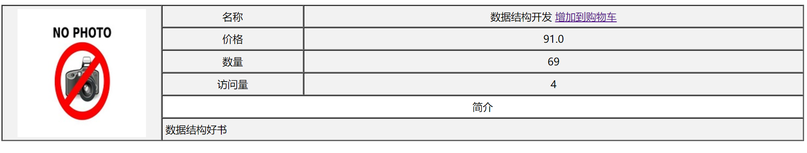
⑩．若用户直接访问购物车页面或结算清单页面，则程序会自动进行拦截，然后提示用户进行登录后再操作，然后自动跳转到登录页面。
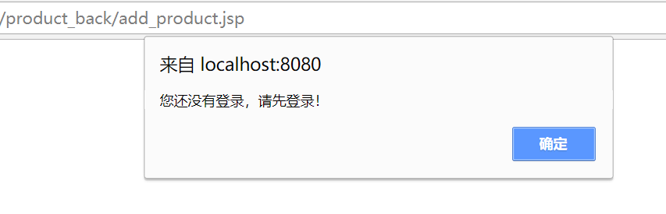

- 实验总结：
总的来说，我觉得这次实验跟前两次实验比较起来就具有很大的难度，不再像前两个实验一样一两天就可以完成。这次实验的逻辑复杂度对我来说很难了。首先在设计几个表的时候就让我犯难了，不清楚表中到底需要几个字段，将哪个字段作为主键，表之间的相互关系等等。后来表设计好了以后，开始设计购物车程序，由于该程序需要的页面比较多，所以最开始没有将每个页面之间的关系理清楚。后来就是逻辑层业务层的编写，虽然再前两个实验中已经对MVC设计模式有了较为熟悉的了解。但是到了这种稍微复杂一点的程序中，又让我犯了些错误。在分页设计上也是一个技术难点，查阅了许多资料后终于清楚了真分页和假分页的区别，在克服重重困难后，终于在老师和同学的帮助下完成了这次实验。这次实验让我成长了许多，对程序的设计又有了更加深入的理解。感谢在这次实验中帮助我的老师和同学们，希望老师以后能多给我这样锻炼的机会。

- 实验环境
- 操作系统：WINDOWS 7及以上
- 开发工具：VC++ 2012
- 实验设备：PC
- 提交文档
提交本实验报告（电子版），文件名命名：学号 姓名《实验X：XXXXXXX》.doc
教师将批阅后（有分数）的全体学生实验报告刻入一张光盘存档，保证光盘可读。
- 附：源代码
package org.wp.dao.impl;

import java.sql.Connection;
import java.sql.PreparedStatement;
import java.sql.ResultSet;
import java.util.List;

import org.wp.dao.IMerberDAO;
import org.wp.vo.Member;

public class MerberDAOImpl implements IMerberDAO{
private Connection conn;
private PreparedStatement pstmt;
public MerberDAOImpl() {}
public MerberDAOImpl(Connection conn) {
this.conn = conn; //数据库连接
}
@Override
public boolean findLogin(Member vo) throws Exception {
boolean flag = false;
String sql = "select name,address,telephone,zipcode,lastdate from member where mid = ? and password = ?";
this.pstmt = this.conn.prepareStatement(sql);
this.pstmt.setString(1, vo.getMid());
this.pstmt.setString(2, vo.getPassword());
ResultSet rs = this.pstmt.executeQuery();
if(rs.next()) {
flag = true;
}
return flag;
}

@Override
public void doUpdateLastdate(String id) throws Exception {
String sql = "update member set lastdate = ? where mid = ?";
this.pstmt = conn.prepareStatement(sql);
this.pstmt.setDate(1, new java.sql.Date(new java.util.Date().getTime()));
this.pstmt.setString(2, id);
this.pstmt.executeUpdate();
}
@Override
public boolean doCreate(Member vo) throws Exception {
boolean flag = false;
String sql = "insert into member(mid,password,name,address,telephone,zipcode,lastdate) values(?,?,?,?,?,?,?) ";
this.pstmt = this.conn.prepareStatement(sql);
this.pstmt.setString(1, vo.getMid());
this.pstmt.setString(2, vo.getPassword());
this.pstmt.setString(3, vo.getName());
this.pstmt.setString(4, vo.getAddress());
this.pstmt.setString(5, vo.getTelephone());
this.pstmt.setString(6, vo.getZipcode());
this.pstmt.setDate(7,new java.sql.Date(vo.getLastdate().getTime())); //将当前时间提交到数据库
if(this.pstmt.executeUpdate() > 0) {
flag = true;
}
return flag;
}
@Override
public Member findById(String id) throws Exception {
Member member = null;
String sql = "select mid,password,name,address,telephone,zipcode,lastdate from member where mid = ? ";
this.pstmt = this.conn.prepareStatement(sql);
this.pstmt.setString(1, id);
ResultSet rs = this.pstmt.executeQuery();
if(rs.next()) {
member = new Member();
member.setMid(rs.getString(1));
member.setPassword(rs.getString(2));
member.setName(rs.getString(3));
member.setAddress(rs.getString(4));
member.setTelephone(rs.getString(5));
member.setZipcode(rs.getString(6));
member.setLastdate(rs.getDate(7));
}
return member;
}
@Override
public boolean doUpdate(Member vo) throws Exception {
boolean flag = false;
String sql = "update member set name = ?,address = ?,telephone = ?,zipcode = ? where mid = ?";
this.pstmt = conn.prepareStatement(sql);
this.pstmt.setString(1, vo.getName());
this.pstmt.setString(2, vo.getAddress());
this.pstmt.setString(3, vo.getTelephone());
this.pstmt.setString(4, vo.getZipcode());
this.pstmt.setString(5, vo.getMid());
this.pstmt.executeUpdate();

if(this.pstmt.executeUpdate() > 0) {
flag = true;
}
return flag ;
}

@Override
public boolean doRemove(String id) throws Exception {
throw new Exception("此方法未实现");
}

@Override
public List<Member> findAll(String keyword) throws Exception {
throw new Exception("此方法未实现");
}

@Override
public List<Member> findAll(String keyword, int intcurrentPage, int lineSize) throws Exception {
throw new Exception("此方法未实现");
}

@Override
public long getAllCount(String keyword) throws Exception {
throw new Exception("此方法未实现");
}
}

package org.wp.dao.impl;

import java.sql.Connection;
import java.sql.PreparedStatement;
import java.sql.ResultSet;
import java.util.ArrayList;
import java.util.Iterator;
import java.util.List;
import java.util.Set;
import org.wp.dao.IProductDAO;
import org.wp.vo.Product;

public class ProductDAOimpl implements IProductDAO {
private Connection conn ;
private PreparedStatement pstmt = null;
public ProductDAOimpl(Connection conn) {
this.conn = conn;
}

@Override
public boolean doCreate(Product vo) throws Exception {
boolean flag = false;
String sql = "insert into product1(pid,name,price,amount,note,photo) values(proseq1.nextval,?,?,?,?,?)";
this.pstmt = this.conn.prepareStatement(sql);
this.pstmt.setString(1, vo.getName());
this.pstmt.setDouble(2, vo.getPrice());
this.pstmt.setInt(3, vo.getAmount());
this.pstmt.setString(4, vo.getNote());
this.pstmt.setString(5, vo.getPhoto());
if(this.pstmt.executeUpdate() > 0) {
flag = true;
}
return flag ;
}

@Override
public boolean doUpdate(Product vo) throws Exception {
boolean flag = false;
String sql = "update product1 set name = ?,note = ?,price = ?,amount = ?,photo = ? where pid = ?";
this.pstmt = this.conn.prepareStatement(sql);
this.pstmt.setString(1, vo.getName());
this.pstmt.setString(2, vo.getNote());
this.pstmt.setDouble(3, vo.getPrice());
this.pstmt.setInt(4, vo.getAmount());
this.pstmt.setString(5, vo.getPhoto());
this.pstmt.setInt(6, vo.getPid());

if(this.pstmt.executeUpdate() > 0) {
flag = true;
}
return flag;
}

@Override
public boolean doRemove(Integer id) throws Exception {
boolean flag = false;
String sql = "delete from product1 where pid = ?";
this.pstmt = this.conn.prepareStatement(sql);
this.pstmt.setInt(1,id);
if(this.pstmt.executeUpdate() > 0) {
flag = true;
}
return flag;
}

@Override
public Product findById(Integer id) throws Exception {
Product pro = null;
String sql = "select pid,name,note,price,amount,count,photo from product1 where pid = ?";
this.pstmt = this.conn.prepareStatement(sql);
this.pstmt.setInt(1, id);
ResultSet rs = this.pstmt.executeQuery();
if(rs.next()) {
pro = new Product();
pro.setPid(rs.getInt(1));
pro.setName(rs.getString(2));
pro.setNote(rs.getString(3));
pro.setPrice(rs.getDouble(4));
pro.setAmount(rs.getInt(5));
pro.setCount(rs.getInt(6));
pro.setPhoto(rs.getString(7));
}
return pro;
}

@Override
public List<Product> findAll(String keyword) throws Exception { //根据关键字查询商品
throw new Exception("此方法未实现");
}

@Override
public List<Product> findAll(String keyword, int currentPage, int lineSize) throws Exception { //查找所有的商品信息，并分页
List<Product> all = new ArrayList<Product>(); //取得所有商品信息
String sql = "select * from ( " +
" select pid,name,note,price,amount,count,photo, ROWNUM rn " +
" from product1 where ( name like ? or note like ? or price like ? or amount like ? ) " +
" and ROWNUM <= ? order by pid ) temp " +
" where temp.rn >?";
this.pstmt = this.conn.prepareStatement(sql);
pstmt.setString(1, "%" + keyword + "%");
pstmt.setString(2, "%" + keyword + "%");
pstmt.setString(3, "%" + keyword + "%");
pstmt.setString(4, "%" + keyword + "%");
pstmt.setInt(5, currentPage * lineSize);
pstmt.setInt(6,(currentPage -1 )*lineSize);
ResultSet rs = pstmt.executeQuery();
while(rs.next()){
Product pro = new Product();
pro.setPid(rs.getInt(1));
pro.setName(rs.getString(2));
pro.setNote(rs.getString(3));
pro.setPrice(rs.getDouble(4));
pro.setAmount(rs.getInt(5));
pro.setCount(rs.getInt(6));
pro.setPhoto(rs.getString(7));
all.add(pro);
}
return all;
}

@Override
public long getAllCount(String keyword) throws Exception {
long count = 0;
String sql ="select count(pid) from product1 " +
" where name like ? or note like ? or price like ? or amount like ?";
this.pstmt = this.conn.prepareStatement(sql); //??????????????????????????????????????????????????????
this.pstmt.setString(1, "%" + keyword + "%");
this.pstmt.setString(2, "%" + keyword + "%");
this.pstmt.setString(3, "%" + keyword + "%");
this.pstmt.setString(4, "%" + keyword + "%");
ResultSet rs = pstmt.executeQuery();
if(rs.next()) {
count = rs.getInt(1);
}
return count;
}

@Override
public List<Product> findAll(Set<Integer> key) throws Exception { //查找已经购买的商品
List<Product> all = new ArrayList<Product>();
StringBuffer sql = new StringBuffer();
sql.append("select pid,name,note,price,amount,count,photo from product1 where pid in ( ");
int count = 0;
Iterator<Integer> iter = key.iterator(); //参数set集合
while(iter.hasNext()){ //拼sql语句
count++;
sql.append(iter.next()) ;
if(count <= key.size() - 1){
sql.append(",");
}
}
sql.append(")");
this.pstmt = this.conn.prepareStatement(sql.toString());
ResultSet rs = pstmt.executeQuery();
while(rs.next()){
Product pro = new Product();
pro.setPid(rs.getInt(1));
pro.setName(rs.getString(2));
pro.setNote(rs.getString(3));
pro.setPrice(rs.getDouble(4));
pro.setAmount(rs.getInt(5));
pro.setCount(rs.getInt(6));
pro.setPhoto(rs.getString(7));
all.add(pro);
}
return all; //返回查找到的已购买的商品集合
}

@Override
public void doUpdateCount(Integer id) throws Exception { //更新点击量
String sql = "update product1 set count = count + 1 where pid = ?";
this.pstmt = this.conn.prepareStatement(sql);
this.pstmt.setInt(1, id);
this.pstmt.executeUpdate();

}
}

package org.wp.daoproxy;

import java.sql.Connection;
import java.util.List;
import org.wp.dao.IMerberDAO;
import org.wp.dao.impl.MerberDAOImpl;
import org.wp.dbc.JDBCUtils;
import org.wp.vo.Member;

public class MemberDAOProxy implements IMerberDAO{
private Connection dbc = null;
private IMerberDAO dao; //实际操作类

public MemberDAOProxy() {
this.dbc = JDBCUtils.getConnection();
this.dao = new MerberDAOImpl(this.dbc); //实际操作类
}

@Override
public boolean findLogin(Member vo) throws Exception {
boolean flag = false;
try {
flag = this.dao.findLogin(vo);
if(flag) {
this.dao.doUpdateLastdate(vo.getMid()); //更新最后一次的登录时间
}
}catch(Exception e) {
throw e;
}finally {
JDBCUtils.closeConn(null, null, dbc); //将数据库连接放回数据库连接池
}
return flag;
}

@Override
public void doUpdateLastdate(String id) throws Exception {
try {
this.dao.doUpdateLastdate(id);;
}catch(Exception e) {
throw e;
}finally {
JDBCUtils.closeConn(null, null, dbc); //将数据库连接放回数据库连接池
}
}
@Override
public boolean doCreate(Member vo) throws Exception {
boolean flag = false;
try {
if(this.dao.findById(vo.getMid()) == null) { //若该用户名没有被注册过才能注册
flag = this.dao.doCreate(vo);
}
}catch(Exception e) {
throw e;
}finally {
JDBCUtils.closeConn(null, null, dbc); //将数据库连接放回数据库连接池
}
return flag;
}

@Override
public Member findById(String id) throws Exception {
Member member = null;
try {
member = this.dao.findById(id);
}catch(Exception e){
throw e ;
}finally {
JDBCUtils.closeConn(null, null, dbc); //将数据库连接放回数据库连接池
}
return member;
}

@Override
public boolean doUpdate(Member vo) throws Exception {
boolean flag = false;
try {
flag = this.dao.doUpdate(vo);
}catch(Exception e){
e.printStackTrace();
}finally {
JDBCUtils.closeConn(null, null, dbc); //将数据库连接放回数据库连接池
}
return flag;
}

@Override
public boolean doRemove(String id) throws Exception {
boolean flag = false;
try {
flag = this.dao.doRemove(id);
}catch(Exception e){
throw e ;
}finally {
JDBCUtils.closeConn(null, null, dbc); //将数据库连接放回数据库连接池
}
return flag;
}

@Override
public List<Member> findAll(String keyword) throws Exception {
List<Member> all = null;
try {
all = this.dao.findAll(keyword);
}catch(Exception e){
throw e ;
}finally {
JDBCUtils.closeConn(null, null, dbc); //将数据库连接放回数据库连接池
}
return all;
}

@Override
public List<Member> findAll(String keyword, int intcurrentPage, int lineSize) throws Exception {
List<Member> all = null;
try {
all = this.dao.findAll(keyword, intcurrentPage, lineSize);
}catch(Exception e){
throw e ;
}finally {
JDBCUtils.closeConn(null, null, dbc); //将数据库连接放回数据库连接池
}
return all;
}

@Override
public long getAllCount(String keyword) throws Exception {
long count = 0;
try {
count = this.dao.getAllCount(keyword);
}catch(Exception e){
throw e ;
}finally {
JDBCUtils.closeConn(null, null, dbc); //将数据库连接放回数据库连接池
}
return count;
}
}

package org.wp.daoproxy;

import java.sql.Connection;
import java.util.List;
import java.util.Set;

import org.wp.dao.IProductDAO;
import org.wp.dao.impl.ProductDAOimpl;
import org.wp.dbc.JDBCUtils;
import org.wp.vo.Product;

public class ProductDAOProxy implements IProductDAO {
private Connection dbc = null;
private IProductDAO dao = null;
long count = 0;
public ProductDAOProxy() {
this.dbc = JDBCUtils.getConnection();
this.dao = new ProductDAOimpl(this.dbc);
}
@Override
public boolean doCreate(Product vo) throws Exception {
boolean flag = false;
try {
flag = this.dao.doCreate(vo);
}catch(Exception e) {
throw e;
}finally {
JDBCUtils.closeConn(null,null,dbc); //将数据库连接放回数据库连接池
}
return flag;
}

@Override
public boolean doUpdate(Product vo) throws Exception {
boolean flag = false;
try {
flag = this.dao.doUpdate(vo);
}catch(Exception e) {
throw e;
}finally {
JDBCUtils.closeConn(null,null,dbc); //将数据库连接放回数据库连接池
}
return flag;
}

@Override
public boolean doRemove(Integer id) throws Exception {
boolean flag = false;
try {
flag = this.dao.doRemove(id);
}catch(Exception e) {
throw e;
}finally {
JDBCUtils.closeConn(null,null,dbc); //将数据库连接放回数据库连接池
}
return flag;
}

@Override
public Product findById(Integer id) throws Exception {
Product pro = null;
try {
pro = this.dao.findById(id);
}catch(Exception e) {
throw e;
}finally {
JDBCUtils.closeConn(null,null,dbc); //将数据库连接放回数据库连接池
}
return pro;
}

@Override
public List<Product> findAll(String keyword) throws Exception {
List<Product> all = null;
try {
all = this.dao.findAll(keyword);
}catch(Exception e) {
throw e;
}finally {
JDBCUtils.closeConn(null,null,dbc); //将数据库连接放回数据库连接池
}
return all;
}

@Override
public List<Product> findAll(String keyword, int intcurrentPage, int lineSize) throws Exception {
List<Product> all = null;
try {
all = this.dao.findAll(keyword, intcurrentPage, lineSize);
this.count = this.dao.getAllCount(keyword); //？？？？？？？？？？？？？？？？？？？？？
}catch(Exception e) {
throw e;
}finally {
JDBCUtils.closeConn(null,null,dbc); //将数据库连接放回数据库连接池
}
return all;
}

@Override
public long getAllCount(String keyword) throws Exception {
return this.count;
}

@Override
public List<Product> findAll(Set<Integer> key) throws Exception {
List<Product> all = null;
try {
all = this.dao.findAll(key);
}catch(Exception e) {
throw e;
}finally {
JDBCUtils.closeConn(null,null,dbc); //将数据库连接放回数据库连接池
}
return all ;
}

@Override
public void doUpdateCount(Integer id) throws Exception {
try {
this.dao.doUpdateCount(id);
}catch(Exception e) {
throw e;
}finally {
JDBCUtils.closeConn(null,null,dbc); //将数据库连接放回数据库连接池
}
}
}

package org.wp.servlet;

import java.io.IOException;
import java.util.ArrayList;
import java.util.List;

import javax.servlet.ServletException;
import javax.servlet.annotation.WebServlet;
import javax.servlet.http.HttpServlet;
import javax.servlet.http.HttpServletRequest;
import javax.servlet.http.HttpServletResponse;

import org.wp.factory.DAOFactory;
import org.wp.vo.Member;

@WebServlet("/Member_Servlet")
public class Member_Servlet extends HttpServlet {
private static final long serialVersionUID = 1L;

protected void doGet(HttpServletRequest request, HttpServletResponse response) throws ServletException, IOException {
String status = request.getParameter("status");
if("member_updatepre".equals(status)) {
this.member_Updatepre(request, response);
}
if("member_update".equals(status)) {
this.member_Update(request, response);
}
if("register".equals(status)) { //进行注册
this.register(request, response);
}

if("registerpre".equals(status)) { //准备注册
this.registerpre(request, response);
}

response.getWriter().append("Served at: ").append(request.getContextPath());
}

protected void doPost(HttpServletRequest request, HttpServletResponse response) throws ServletException, IOException {
doGet(request, response);
}
//=================================================================================================================

protected void member_Updatepre(HttpServletRequest request, HttpServletResponse response)
throws ServletException, IOException { //准备修改管理员信息 后台修改
String pages = "errors.jsp";
String id = (String)request.getSession().getAttribute("mid");
try {
Member mem = DAOFactory.getMemberDAOInstance().findById(id); //查询到登录人的信息
request.setAttribute("mem", mem);
} catch (Exception e) {
e.printStackTrace();
}

pages = "product_back/member_update.jsp";
request.getRequestDispatcher(pages).forward(request, response);
}
protected void member_Update(HttpServletRequest request, HttpServletResponse response)
throws ServletException, IOException { //修改管理员信息
String pages = "errors.jsp";

String msg = "修改用户信息失败！";

boolean flag = false;
String name = request.getParameter("name");
String address = request.getParameter("address");
String telephone = request.getParameter("telphone");
String zipcode = request.getParameter("zipcode");
String id = (String)request.getSession().getAttribute("mid");

Member mem = new Member();
mem.setName(name);
mem.setAddress(address);
mem.setTelephone(telephone);
mem.setZipcode(zipcode);
mem.setMid(id);

try {
flag = DAOFactory.getMemberDAOInstance().doUpdate(mem); //执行修改
} catch (Exception e) {
e.printStackTrace();
}
if(flag){
msg = "修改用户信息成功！";
}
pages = "product_back/member_operate_do.jsp";
request.setAttribute("msg", msg);
request.getRequestDispatcher(pages).forward(request, response);
}

protected void registerpre(HttpServletRequest request, HttpServletResponse response)
throws ServletException, IOException { //准备注册
String pages = "errors.jsp";

pages = "login/register.jsp";
request.getRequestDispatcher(pages).forward(request, response);
}

protected void register(HttpServletRequest request, HttpServletResponse response)
throws ServletException, IOException { //进行注册 注册到member表 不是admin表，所以注册了也无法登录，需要修改
String pages = "errors.jsp";
boolean flag = false;

Member member = new Member();
member.setMid(request.getParameter("mid"));
member.setPassword(request.getParameter("password"));
member.setName(request.getParameter("name"));
member.setTelephone(request.getParameter("telephone"));
member.setZipcode(request.getParameter("zipcode"));
member.setAddress(request.getParameter("address"));
member.setLastdate(new java.util.Date());
List<String> errors = new ArrayList<String>();
try {
flag = DAOFactory.getMemberDAOInstance().doCreate(member);
} catch (Exception e) {
e.printStackTrace();
}
if(flag){
pages = "login/front_login.jsp";
errors.add("注册成功!请登录");
}else {
pages = "login/register.jsp";
request.setAttribute("msg", "注册失败,请重新注册！");
}
request.setAttribute("errors", errors);
request.getRequestDispatcher(pages).forward(request, response);
}
}

package org.wp.servlet;

import java.io.IOException;
import java.util.Enumeration;
import java.util.HashMap;
import java.util.Iterator;
import java.util.List;
import java.util.Map;
import java.util.Set;

import javax.servlet.ServletException;
import javax.servlet.annotation.WebServlet;
import javax.servlet.http.HttpServlet;
import javax.servlet.http.HttpServletRequest;
import javax.servlet.http.HttpServletResponse;

import org.wp.factory.DAOFactory;
import org.wp.factory.ServerFactory;
import org.wp.vo.Member;
import org.wp.vo.Product;

@WebServlet("/ProductFrontServlet")
public class ProductFrontServlet extends HttpServlet { //购物车前台servlet
private static final long serialVersionUID = 1L;

protected void doGet(HttpServletRequest request, HttpServletResponse response) throws ServletException, IOException {
String url = request.getContextPath(); //得到当前目录，即根目录
request.setAttribute("url", url);
String pages = "errors.jsp";
String status = request.getParameter("status"); //取得页面的提交状态，根据提交状态分别做出响应
if(!(status == null || "".equals("status"))) {
if("add_cars".equals(status)) { //若提交的状态是加入购物车
this.add_cars(request, response); //调用执行加入购物车操作
}
if("product_cars".equals(status)) {
this.product_cars(request, response);
}
if("order_cars".equals(status)) {
this.order_cars(request, response);
}
if("update_car".equals(status)) {
this.update_car(request, response);
}
if("member_updatepre".equals(status)) {
this.member_updatepre(request, response);
}
if("member_update".equals(status)) {
this.member_update(request, response);
}
if("show".equals(status)) {
this.show(request, response);
}

}else {
request.getRequestDispatcher(pages).forward(request, response); //跳转到出错页面
}

response.getWriter().append("Served at: ").append(request.getContextPath());
}

protected void doPost(HttpServletRequest request, HttpServletResponse response) throws ServletException, IOException {
doGet(request, response);
}
//============================================================================================================================

protected void add_cars(HttpServletRequest request, HttpServletResponse response) throws ServletException, IOException {
String pages = "errors.jsp";
//要购买的商品编号 负责创建购买商品的集合，和对商品购买数量加一
int pid = Integer.parseInt(request.getParameter("pid"));
Map<Integer,Integer> cars = (Map<Integer,Integer>)request.getSession().getAttribute("allpid"); //在session范围内取得全部已经购买的商品
//但是如果是第一次购买的话肯定取得不到
if(cars == null){ //实例化一个新的Map对象用来存放购买的商品
cars = new HashMap<Integer,Integer>(); //创建一个用于存放购买商品的集合
}
if(cars.get(pid) == null){ //还没有购买商品，取得商品对应pid的value值
cars.put(pid, 1); //此商品购买了一个
}else{
int val = cars.get(pid); //通过点击后传过来的商品的pid（key）取得对应的购买数量（value）
val++; //将商品数量加1
cars.put(pid, val); //重新将pid放入map集合，覆盖已有内容
}
request.getSession().setAttribute("allpid",cars); //将所购买的商品pid和数量保存在session属性范围内
pages = "ProductFrontServlet?status=product_cars";
request.getRequestDispatcher(pages).forward(request, response);

}

protected void member_updatepre(HttpServletRequest request, HttpServletResponse response) throws ServletException, IOException {
String pages = "errors.jsp"; //在前台的顾客修改登录的信息
String id = (String)request.getSession().getAttribute("mid"); //取得登录用户的登录ID
try {
Member member = DAOFactory.getMemberDAOInstance().findById(id); //根据ID找到登录的用户信息
request.setAttribute("member", member);
pages = "product_front/member_update.jsp";
} catch (Exception e) {
e.printStackTrace();
}
request.getRequestDispatcher(pages).forward(request, response);
}

protected void member_update(HttpServletRequest request, HttpServletResponse response) throws ServletException, IOException {
String pages = "errors.jsp"; //执行修改顾客的登陆信息
String msg = "修改用户信息失败！";
boolean flag = false;
String name = request.getParameter("name");
String address = request.getParameter("address");
String telephone = request.getParameter("telphone");
String zipcode = request.getParameter("zipcode");
String id = (String)request.getSession().getAttribute("mid");

Member mem = new Member();
mem.setName(name);
mem.setAddress(address);
mem.setTelephone(telephone);
mem.setZipcode(zipcode);
mem.setMid(id);

try {
flag = DAOFactory.getMemberDAOInstance().doUpdate(mem);
} catch (Exception e) {
e.printStackTrace();
}
if(flag){
msg = "修改用户信息成功！";
}
pages = "product_front/product_operate_do.jsp";
request.setAttribute("msg", msg);
request.getRequestDispatcher(pages).forward(request, response);
}
protected void product_cars(HttpServletRequest request, HttpServletResponse response) throws ServletException, IOException {
String pages = "errors.jsp";
Map<Integer,Integer> cars = (Map<Integer,Integer>)request.getSession().getAttribute("allpid"); //取得所购买商品的map集合
if(cars != null){
try {
Set<Integer> key = cars.keySet(); //取得全部的key pid
List<Product> all = DAOFactory.getIProductDAOInstance().findAll(key); //根据pid取得已购买商品
request.setAttribute("all", all);
request.setAttribute("cars", cars);
} catch (Exception e) {
e.printStackTrace();
}
pages = "product_front/product_cars.jsp";
}

request.getRequestDispatcher(pages).forward(request, response);
}
protected void order_cars(HttpServletRequest request, HttpServletResponse response) throws ServletException, IOException {
String pages = "errors.jsp"; //结算购物车
Map<Integer,Integer> cars = (Map<Integer,Integer>)request.getSession().getAttribute("allpid"); //取得购买的商品集合(保存购买商品的pid和购买数量)
if(cars != null){
try {
double sum = 0; //用于保存购买的商品的总价钱
Set<Integer> key = cars.keySet(); //取得全部的key pid
String id = (String)request.getSession().getAttribute("mid");
Map<String,Object> maps = ServerFactory.getIFrontServerDAOInstance().findOrder(id, key); //取得保存用户信息和商品信息的集合
Member member = (Member)maps.get("member"); //取得用户信息
List<Product> pros = (List<Product>)maps.get("product") ; //取得所有的商品信息
Iterator<Product> iter = pros.iterator();
while(iter.hasNext()){ //将查询到的已经购买的商品进行显示
Product pro = iter.next();
sum = sum + pro.getPrice() * cars.get(pro.getPid());
}
request.setAttribute("member", member); //将取得的信息保存在属性范围中
request.setAttribute("product", pros);
request.setAttribute("cars", cars); //将购物车的所有商品信息保存在属性范围之中，以便在结算页面进行显示购买的数量
request.setAttribute("sum", sum);
pages = "product_front/product_order_list.jsp";
} catch (Exception e) {
e.printStackTrace();
}
}
request.getRequestDispatcher(pages).forward(request, response);
}

protected void update_car(HttpServletRequest request, HttpServletResponse response) throws ServletException, IOException {
String pages = "errors.jsp"; //修改购物车信息

//要购买的商品编号
Enumeration allpid = request.getParameterNames(); //取得所有的提交数据，即所有的以商品编号为name的input框名字，返回为枚举类型
Map<Integer,Integer> cars = (Map<Integer,Integer>)request.getSession().getAttribute("allpid"); //取得所有已经购买商品的pid和数量的map集合
if(cars == null){ //实例化一个新的Map对象
cars = new HashMap<Integer,Integer>();
}
boolean flag = true;
while(allpid.hasMoreElements()){
String paramName = (String) allpid.nextElement();
if(flag) { //因为所取得的参数多了一个status，所以要去除这个多余的参数
paramName = (String)allpid.nextElement();
flag = false;
}
try{
int pid = Integer.parseInt(paramName); //取得pid
int val = Integer.parseInt(request.getParameter(paramName)); //得到购买的商品件数，即得到提交过来的input框的值
cars.put(pid, val); //重新放回集合，覆盖原来相同pid的值
}catch(Exception e){
e.printStackTrace();
}
}
pages = "ProductFrontServlet?status=product_cars";
request.getRequestDispatcher(pages).forward(request, response);
}

protected void show(HttpServletRequest request, HttpServletResponse response) throws ServletException, IOException {
String pages = "errors.jsp"; //修改购物车信息
int pid = 0;
try{
pid = Integer.parseInt(request.getParameter("pid"));
Product pro = ServerFactory.getIFrontServerDAOInstance().
findProduct(pid,(Boolean)request.getSession().getAttribute(pid + "")==null); //查找到了该商品,防止恶意刷新点击量
if(pro != null){
request.getSession().setAttribute(pid+"", false); //增加之后变为false
}
request.setAttribute("pro", pro); //将查找到的商品保存到request属性范围
pages = "product_front/product_show.jsp";
}catch(Exception e){
e.printStackTrace();
}

request.getRequestDispatcher(pages).forward(request, response);
}

}

